19 December 2023
﻿

Public consultation

regarding

the allocation of mobile radio frequencies
available from 2029 for the provision of telecommunication services in Switzerland

Contents

1 Introduction 3
2 Background 4
2.1 Overview of frequency spectrum of mobile telecommunication licence holders 4
2.2 Frequency usage rights expiring at the end of 2028 4
2.3 Technology neutrality of mobile telecommunication licences 5
3 Possible new frequency ranges for mobile telecommunication 5
3.1 Introduction 5
3.2 Frequencies in the 6GHz range 6
3.3 Frequencies in the millimetre wave range 26GHz and 40GHz 6
Questionnaire 7
Publication information 7
Administrative information 7
Respondent's details 8
General questions 8
Questions about the planned frequency allocation procedure in 2027 8
Questions about mobile radio licences available from 2029 and conditions 8
Detailed questions about available frequencies 9
Detailed questions on possible new frequency bands 10

- Introduction
The Federal Communications Commission (ComCom) has instructed the Federal Office of Communications (OFCOM) to begin preparatory work on the allocation of frequencies available from 2029 for the provision of telecommunication services for third parties.
As a first step, OFCOM is conducting a public consultation in which it invites all interested parties to give feedback on the allocation of mobile radio frequencies which will be available from 2029 for the provision of telecommunication services in Switzerland. The consultation runs until 26 February 2024. The aim is to collect a list of the needs of interested parties regarding the use of mobile frequencies in order to establish whether sufficient frequencies will be available from 1 January 2029. This relates to current frequency usage rights allocated to mobile telecommunication licence holders in 2012, which expire at the end of 2028, and to additional frequencies that may be available for mobile telecommunication in the future.
The volume of data transmitted via mobile devices is constantly increasing. The reasons for this are the high market penetration of smartphones, increasing data use (primarily driven by video services) and the increase in devices and objects that are wirelessly connected to the internet. As a result of these developments, additional frequencies for mobile telecommunication systems (IMT) are likely to be required. Interest in these frequencies has also increased owing to the wide availability of systems and devices. In addition to the mobile telecommunication licence holders who provide networks based on these frequencies, other potential users, such as transport companies and the emergency services, may also be interested in frequency usage rights.
If the present consultation shows that there may not be enough frequencies available to provide telecommunication services, ComCom generally issues a public call for tenders.

- Background
  - Overview of frequency spectrum of mobile telecommunication licence holders
The three mobile telecommunication licence holders Salt Mobile AG, Sunrise GmbH and Swisscom AG were able to acquire a broad range of frequency usage rights for the provision of public mobile telecommunication services in the award procedures carried out in 2012 and 2019. The duration of the mobile telecommunication licences was set at 15 years in both 2012 and 2019 and will expire on 31 December 2028 and 17 April 2034 respectively.
The licence holders are currently allocated 1020 MHz in the following frequency bands:

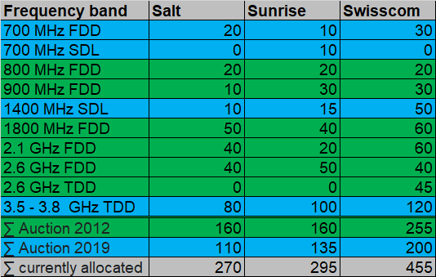
Legend:
Green background: Frequencies allocated in the 2012 auction, valid until 31 December 2028

Blue background: Frequencies allocated in the 2019 auction, valid until 17 April 2034

Σ: Total

Figure 1: Bandwidths in MHz currently allocated to mobile telecommunication licence holders

  - Frequency usage rights expiring at the end of 2028
The following frequency usage rights will expire on 31 December 2028:
- 2 x 265 MHz for FDD use, distributed across the five frequency bands 800, 900, 1800, 2100 and 2600 MHz;
- 1 x 45 MHz for TDD use in the 2600 MHz frequency band.
The following chart shows a breakdown of the frequency usage rights of the respective mobile communication licence holders expiring at the end of 2028:
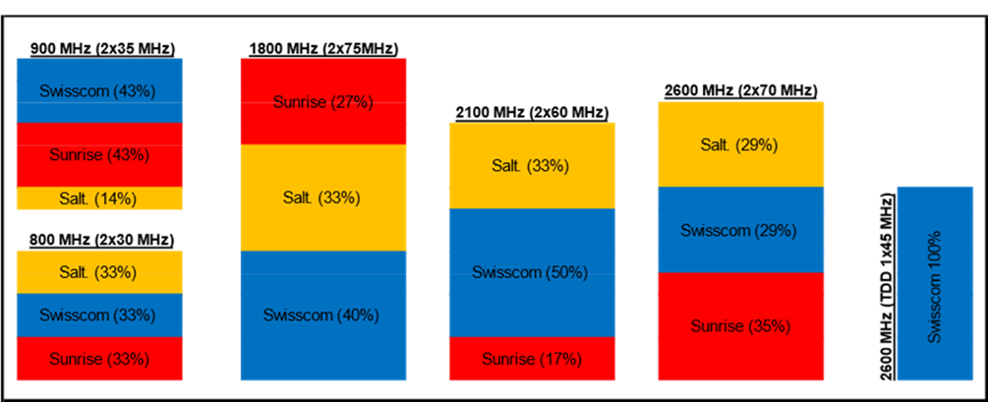
Figure 2: Shares of operators Salt, Sunrise and Swisscom in the frequency usage rights due to expire in 2028

  - Technology neutrality of mobile telecommunication licences
The frequency usage rights allow the free choice of mobile communication technology subject to the harmonised standards. This means that mobile telecommunication licence holders have the freedom to use the technologies that best meet their individual needs, e.g. 2G, 3G, 4G, 5G, 6G (technology neutrality). This encourages the efficient use of the spectrum and also emphasises the importance to the national economy of an advanced mobile communication infrastructure.
Technology neutrality makes it easier for licence holders to switch technologies in the existing mobile networks during the term of the mobile telecommunication licences. The replacement of 2G operations during the period of the current mobile telecommunication licences is practically complete and 3G is currently being replaced. Innovative approaches such as network slicing or non-terrestrial networks (NTN) are leading to the replacement of older technologies. With network slicing, virtual mobile networks can be operated within a physical network. NTN allows coverage to be improved in more remote areas. However, the use of NTNs in Europe is currently not possible due to a lack of international and national radio regulations.

- Possible new frequency ranges for mobile telecommunication
  - Introduction
New developments and digitalisation mean that additional frequencies are likely to be required for mobile telecommunications (IMT). New frequency ranges may therefore become available in Switzerland in the next few years.
Any allocation of frequencies for mobile telecommunications in the national frequency allocation plan (NFAP) does not necessarily mean that these frequencies will be available to licence holders or service providers. OFCOM manages the frequency spectrum and must ensure equal access to it. It may segment the frequency allocations in the mobile telecommunication sector according to need and make them available for use by interested parties.
It is therefore not yet clear whether any new frequency ranges for mobile communications in Switzerland can be made available in the next allocation. Nonetheless, the interested parties are already being asked in this consultation what their frequency needs are.
  - Frequencies in the 6GHz range
At the World Radiocommunication Conference (WRC-23), it was decided to allocate the 6 GHz band (6425 - 7125 MHz) to mobile radio (IMT) and RLAN in addition to the existing radio services. There is no corresponding allocation in the USA, India and China. The technical and regulatory conditions are now being worked out at European level. It should be noted that this frequency range in Switzerland is currently assigned to radio relay links and partly to satellite communication, and has already been partially allocated. The joint use of this frequency range will mean that restrictions (e.g. in geographical terms, restriction to conurbations, indoor use) will be necessary in the event of any future use for mobile communications.
  - Frequencies in the millimetre wave range 26GHz and 40GHz
The 24.25–27.50GHz and 40.5–43.5GHz frequency ranges are referred to in telecommunications as the 26GHz band and 40GHz band respectively and are generally categorised as millimetre waves. Both frequency bands are already harmonised at European level. However, before these frequencies can be made available in Switzerland, the necessary conditions must first be created at national level (e.g. changes to the NFAP, RIR, NIRO and associated guidelines). These frequency ranges in Switzerland are currently allocated and partially assigned to radio relay links, satellite communication and other telecom services.

Questionnaire

Publication information
The statements submitted will be published on OFCOM's website. OFCOM endeavours to publish documents barrier-free in accordance with the Disability Discrimination Act (DDA; SR 151.3). Please therefore submit your statements both as a Word file and PDF.

Should your statements contain confidential information, please also submit a version without this information. The content covered must be clearly described and reasons given as to why the information is confidential. Confidentiality interests must be kept to a minimum. The non-confidential version will be published on the website.

Administrative information
Please answer the questions below and give reasons for your answers.
Please send the completed questionnaire until 26 February 2024 to the following address (electronic version):
Email: tp-nd@bakom.admin.ch
Federal Office of Communications
Networks and Services Section
Zukunftsstrasse 44
2501 Biel/Bienne

Respondent's details
Name of the company/organisation/authority:
Contact person (first name and surname):
Street:
Postcode, city:
Tel.:
Email:

General questions
- How do you think the market will develop long term (mobile technology / applications / end devices / mobile traffic volume etc.)?
- The issue of integrating non-terrestrial (satellite-based) networks into mobile networks (direct connection between terminal device and satellite) will be addressed at the next World Radiocommunication Conference in 2027. How do you envisage developments and the possible integration of such networks, and what effect will they have?
- How do you envisage the use of certain mobile radio frequency bands in airspace (e.g. for drones) going forward, and what will its impact be?
- What is your view on the use of Fixed Wireless Access (FWA) and which frequencies do you consider to be fundamentally appropriate? And which one are particularly well suited?

Questions about the planned frequency allocation procedure in 2027
- What type of allocation procedure (auction, criteria-based allocation, direct allocation) should be used to allocate the frequency bands? Should all frequency bands be allocated using the same type of procedure?
- If an award procedure is organised, do you intend to participate?
- An initial award procedure is planned for 2027 and a second one will probably be held in 2032. What is your position on the intended procedure?

Questions about mobile radio licences available from 2029 and conditions
- How long should the new mobile radio licences be valid for?
- What is your opinion about conditions of use such as service coverage, cybersecurity, safety communication? Should the current conditions be supplemented with further conditions and if so, which ones?

Detailed questions about available frequencies
800MHz (Band 20)

- How great do you think your demand for frequencies in this bandwidth will be from 2029?
- If you were already allocated frequencies in this bandwidth in the 2012 allocation procedure, would you like to continue using them to the same extent? What effect would it have if you were no longer allocated the same frequencies or received fewer in this bandwidth?
- In your opinion, is there a minimum requirement and if so, how great is it?
- What else should be taken into account when allocating this frequency band?
900MHz (Band 8)

- How great do you think your demand for frequencies in this bandwidth will be from 2029?
- If you were already allocated frequencies in this bandwidth in the 2012 allocation procedure, would you like to continue using them to the same extent? What effect would it have if you were no longer allocated the same frequencies or received fewer in this bandwidth?
- In your opinion, is there a minimum requirement and if so, how great is it?
- What else should be taken into account when allocating this frequency band?
1800MHz (Band 3)

- How great do you think your demand for frequencies in this bandwidth will be from 2029?
- If you were already allocated frequencies in this bandwidth in the 2012 allocation procedure, would you like to continue using them to the same extent? What effect would it have if you were no longer allocated the same frequencies or received fewer in this bandwidth?
- In your opinion, is there a minimum requirement and if so, how great is it?
- What else should be taken into account when allocating this frequency band?
2100MHz (Band 1)

- How great do you think your demand for frequencies in this bandwidth will be from 2029?
- If you were already allocated frequencies in this bandwidth in the 2012 allocation procedure, would you like to continue using them to the same extent? What effect would it have if you were no longer allocated the same frequencies or received fewer in this bandwidth?
- In your opinion, is there a minimum requirement and if so, how great is it?
- What else should be taken into account when allocating this frequency band?
2600MHz (Band 7)

- How great do you think your demand for frequencies in this bandwidth will be from 2029?
- If you were already allocated frequencies in this bandwidth in the 2012 allocation procedure, would you like to continue using them to the same extent? What effect would it have if you were no longer allocated the same frequencies or received fewer in this bandwidth?
- In your opinion, is there a minimum requirement and if so, how great is it?
- What else should be taken into account when allocating this frequency band?
2600MHz TDD (Band 38)

- How great do you think your demand for frequencies in this bandwidth will be from 2029?
- If you were already allocated frequencies in this bandwidth in the 2012 allocation procedure, would you like to continue using them to the same extent? What effect would it have if you were no longer allocated the same frequencies or received fewer in this bandwidth?
- In your opinion, is there a minimum requirement and if so, how great is it?
- What else should be taken into account when allocating this frequency band?

Detailed questions on possible new frequency bands
It is not yet known to what extent these frequency bands will be available in Switzerland in the future.
6GHz (Band 104)

- How do you rate the attractiveness and the economic and social benefits of this frequency band?
- Are you interested in usage rights in this frequency range? If so, what are your requirements?
- For which application and coverage scenarios are these frequencies suitable?
- Do network equipment and terminal devices that can be used in this frequency range already exist? If not, when can they be expected?
- What other aspects need to be considered in this frequency band?
26GHz (Band 258)

- How do you rate the attractiveness and the economic and social benefits of this frequency band?
- Are you interested in usage rights in this frequency range? If so, what are your requirements?
- For which application and coverage scenarios are these frequencies suitable?
- Do network equipment and terminal devices that can be used in this frequency range already exist? If not, when can they be expected?
- What other aspects need to be considered in this frequency band?
40GHz (Band 259)

- How do you rate the attractiveness and the economic and social benefits of this frequency band?
- Are you interested in usage rights in this frequency range? If so, what are your requirements?
- For which application and coverage scenarios are these frequencies suitable?
- Do network equipment and terminal devices that can be used in this frequency range already exist? If not, when can they be expected?
- What other aspects need to be considered in this frequency band?

Further remarks

- Do you have other remarks, suggestions, etc.?

International Mobile Telecommunications (IMT), family of mobile radio systems: UMTS (3G), LTE (4G), New Radio (5G), WiMax (IEEE 802.16)
Art. 22a TCA
FDD: Frequency division duplex
TDD: Time division duplex
ETSI EN 301 908; IMT cellular networks; Harmonised standard for access to radio spectrum;
International Mobile Telecommunications (IMT), family of mobile radio systems: UMTS (3G), LTE (4G), New Radio (5G), WiMax (IEEE 802.16)
In the NFAP, frequency ranges for mobile telecommunications are labelled MOBILE and MFCN/IMT.
Art. 25 TCA.
Radio Local Area Network
See ECC Decision (22)07 (cept.org)
Wireless broadband coverage of households via the stationary use of outdoor antennas on buildings, from which signals are brought into the buildings via cable

