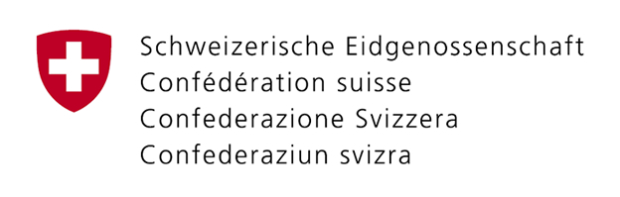
Bundesamt für Kommunikation BAKOM
Office fédéral de la communication OFCOM
Ufficio federale delle comunicazioni UFCOM
Uffizi federal da communicaziuns UFCOM
Zukunftstrasse 44 / Rue de l’Avenir 44
Postfach / Case postale
CH-2501 Biel-Bienne
Tel./Tél. +41 58 460 58 31
e-mail: kf-fk@bakom.admin.ch

Application for a wireless camera licence

Please send this form by e-mail or fax at least 10 days before the beginning of an event to kf-fk@bakom.admin.ch or fax number: +41 (0) 58 463 18 24.

Further information can be obtained by calling the following numbers:
direct: +41 (0) 58 460 58 31 or through the central switchboard: +41 (0) 58 460 55 11

Applicant
Company Postal code
Address Place

Administrative contact. Mobile Telephone
E-mail

Technical contact Mobile Telephone
E-mail

Invoice address
Company Postal code
Address Place

Term of licence
from : to :

Purpose of transmission (event) :

Address of event location :

Precise Swiss coordinates :

A) Camera(s) : Number of units :
Make and model :
Requested frequency(ies) : MHz
Setting range: from MHz to MHz, in steps of MHz
Unit power : dBm
RF bandwith : MHz
Antenna type / gain : / dBi
Effective isotropically radiated power EIRP : dBm

B) Telemetry transmitter(s) : No of units :
Make and model :
Requested frequency(ies) : MHz
Channel spacing : kHz
Effective isotropically radiated power (in W or mW) :

Reservations : Interference-free operation cannot be guaranteed for wireless cameras; interference should not be caused to other radio users

If a wireless camera is found to be causing interference to other radio users, it must be taken out of service immediately.

Comments :

Place, date signature :

